BASINGSTOKE CHESS CLUB NEWSLETTER (JUNE 2023)
PRIZEGIVING EVENING
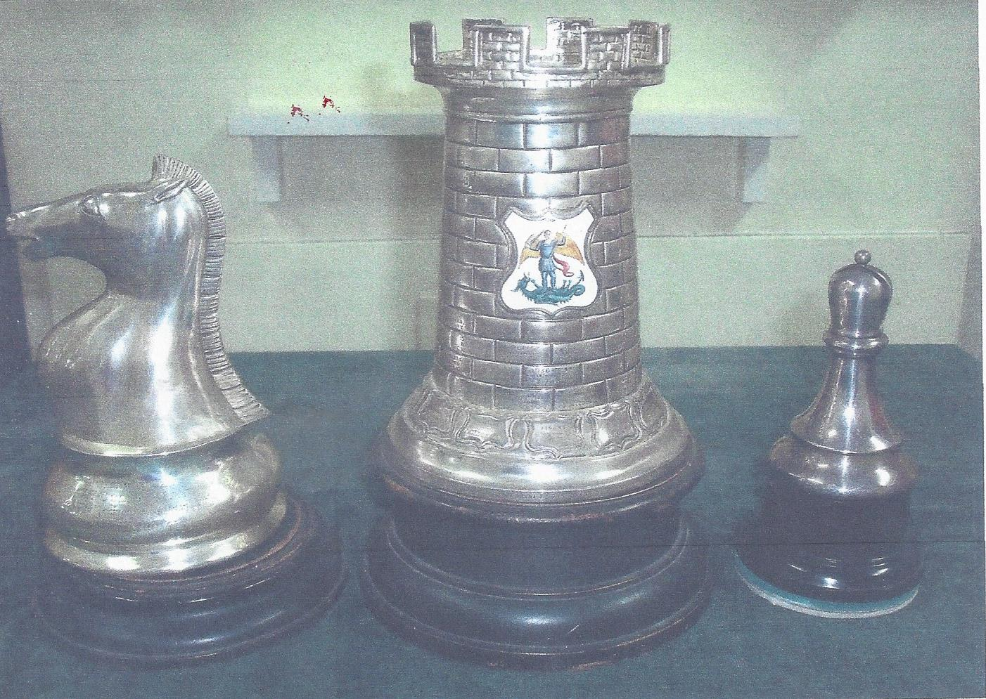
WEDNESDAY 14th JUNE 2023
The Presentation of the season’s awards will take place on the above date. A list of the awards is given below. As with previous Prize giving evenings a rapid play competition will be held with 10 minutes for all moves. Small prizes will be awarded for the Main competition and also the Plate competition. Members are invited to bring along nibbles and snacks and possibly soft drinks as in previous occasions. An enjoyable evening is planned after a relatively successful season.
2022 Awards; Joe French Cup
Winner Steven Jones Finalist Jamie Chilton
Charles Henshaw Shield
Winner Charles Oluwadare Finalist Ralph Morley

2023 Awards:
Southampton League Division 2 Winners (8)
Jamie Chilton (captain), Steven Jones, Raja Pentakota, Graham Phillips,
Ivan Stipcevic, Richard Thurstans, Colin Knight, Mo Negargar
Southampton League Division 3 Runners Up (7)
Charles Oluwadare, Harry Smith, Ralph Morley, Colin Knight, Megan Birch, Andrew Birch, Liam Durangparang.

CHESS LEAGUES
Basingstoke A duly won Division 2 of the Southampton League. In the final home match against Hamble A wins from Jamie Chilton, Ivan Stipcevic and a draw from Steven Jones recorded 2 ½ points. An additional point was gained when an opposing player had trouble with the trains and conceded a default enabling a 3 ½ to 1 ½ win. For the forthcoming season the club have again entered 4 teams into the Southampton League. The A team will move up to Division 1 and the B,C and D teams will again enter Divisions 3,4 and 5.
A consultation was conducted with members regarding possible re-entry into the Berkshire and also Borders League’s. In both cases there was some interest. The players wishing to play in the Berkshire League covered a wide range of playing strength. Probably not strong enough to compete in Division 1 but too strong for the bottom league Division 3.
In the case of the Borders League a possible entry could be considered into one of the lower leagues. However before any entry can be considered then the teams will require team captains and members willing to take on the admin part of the above leagues. There is still some time before the respective AGM’s so anyone who wishes to take on the roles is welcome to get in touch.
http://www.sotonchessleague.org.uk/
BASINGSTOKE JUNIOR INDIVIDUAL CHAMPIONSHIP.
The above competition has been scheduled for Sunday 4th June 2023. The start time is 10.30am and is likely to finish around 1.30pm. Entrants must be under 15.All entrants will receive a trophy as in previous years. This will be the final junior event of the season which restarts in September.
DELANCEY MEGAFINALS

2023 Hampshire Megafinal
£30.00
Date: Sunday 25th June
Venue: Winchester College (New Hall), College Street, Winchester, Hampshire, SO23 9NF
Eligibility: Open to all juniors born after 31/08/2004
Schedule: Arrival from 9.30 for a 10.00 start. Approximate finish time 17.00
Organiser Details: Maha Chandar, kidschess@hotmail.com
Closing date for last entries: 22nd June
Time control: 20 minutes + 10 seconds
ECF rated: Yes
Other information:
***Please note the organiser has the right to make changes to the above on the day if required

DISCOVERY CENTRE:
There was a good attendance of 24 for the May Family morning. The next Discovery Centre chess morning will be in September.
BASINGSTOKE CHESS LEAGUE
Current positions.
Matches played in brackets Basing 20 ½ (4), Tadley 17 (3), Oakridge 17 (3)
Central 16 ½ , Popley 10 (3), Kempshott 9 (2)

Results/Fixtures attached.

STUART KNOX CARTOONS: Thank you to Stuart for providing the funny cartoons.

BASINGSTOKE GAZETTE: Attached is the the full article sent into the Gazette which was published on line and part published in the main newspaper.
BASINGSTOKE COUNCIL: Basingstoke Council have invited Chess club members to participate in the August Friday Town centre events. These will include a giant chess set and the invitation email is below.
Good morning,

Hope you had a lovely long weekend!

We are currently programming our summer FriYAY events which take place every Friday in August. The events run from 11am to 3pm and take place in Basingstoke Town Centre/ War Memorial Park.

The theme is Sport and Play and we were wondering if you would like to get involved? We have a giant chess set that has gone down brilliantly at other events and was thinking Basingstoke Chess Club could lead some sessions to get kids involved and teach them how to play. The events are free for people to take part but you are more than welcome to bring flyers and promotional material to raise the profile of the club in a town centre location

Let me know your thoughts

Thank you,
Olivia

Olivia Bone
Economy and Culture Assistant
Basingstoke and Deane Borough Council
Olivia.Bone@basingstoke.gov.uk
www.basingstoke.gov.uk
@BasingstokeGov @BasingstokeGov

CLUB WEBSITE: Keep up to date with Basingstoke Chess Club news from the club’s website. https://www.basingstokechessclub.co.uk/

Best Regards, DAVID

