BASINGSTOKE CHESS CLUB NEWSLETTER (April 2024)
JUNIOR CHESS
STEVEN JONES JUNIOR COACHING

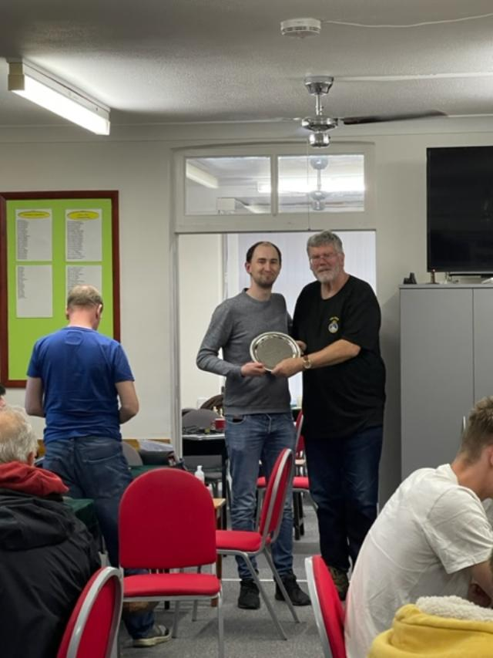
All being well we hope to have Steven Jones spend time with the Junior Club on Wednesday 17th April 2024. The start time is scheduled for 5.30pm. Steven was second in the British Championship last season and is seen above receiving a plate in recognition of the achievement from club treasurer Peter Beldaus.
JUNIOR CHESS DIARY:
Wednesday 3rd April: No Junior Club. Easter holiday
Wednesday 10th April: Junior Club
Wednesday 17th April : Junior Club
Wednesday 24th April: Junior Club
The Delancey Mega Finals are scheduled to be held on Sunday 23rd June 2024 at Winchester College. Details from Maha Chander at kidschess@hotmail.com
The entry fee is £30 and it is full day of chess.
LEAGUE CHESS
Approaching the end of the season it is apparent all five teams have performed well and achieved good results.
SOUTHAMPTON LEAGUE:
The A team look to be heading for a very creditable second place in their first season in Division 1. The only match played saw a draw 2 ½ - 2 ½ against second place challengers Ringwood. Two of our younger players gained points. Harry Smith gained a draw on Board 2 while Ralph Morley won on board 5. However the match on Board 1 will go down to the best individual win of the season by Raja Pentakota. In a totally locked pawn position with only Bishops of opposite colours remaining, Raja found a way to guide his King around the board before sacrificing the Bishop for two pawns which went on to gain a Queen. Sad to relate Salisbury A defaulted on the day of the match being unable to raise a team. Ringwood now need to win 5-0 against Fareham A who have won the league to claim second place.
The B team had one fixture which was lost 3 ½ - 1 ½ at Salisbury B. The points came from a win by Scott Leadbetter and a draw by Mo Negargar. The team have one fixture left and are certain to finish mid table.
The C team have faltered slightly in the latter stages of the season. A home fixture saw a narrow 2 ½ - 1 ½ loss against a strong Southampton University C team. A win from captain David Long and a draw from Colin Knight not quite enough. The second match was at Winchester C and a 2-2 draw was achieved. The points came via a win from Richard Thurstans and draws from Scott Leadbetter and David Long. With just one match remaining the team will face Chandlers Ford C away who are the only team who can overhaul our C team. A win for Chandlers Ford would put them level on points. However our C team have the better board count and only a 4-0 win will prevent a league title win for our team. Good luck to David and the team.
The D team have had a quiet month with no matches to play. However results elsewhere mean they are still in contention to win the Division. However this will require winning both the last two matches.
Robertson Cup: The A team (combined A and B teams) visit Ringwood in the Semi Final.
Roberston Plate: The B team (combined C and D teams) have been re-instated back into the competition despite losing 3-1 against Southampton University at home. The League established the Uni had played an ineligible player and were promptly thrown out of the Robertson Plate. In the final our team will meet Chandlers Ford B.

BORDERS LEAGUE
The Borders League team concluded their fixtures in Division 5. In a very small league of just 4 teams they finished second. This was creditable as they were the lowest graded team in the league.
Both the final two matches were against Guildford E. Despite being outgraded by over 100 points a board the home fixture ended in a remarkable 5-0 win. The points came from wins by David Long, Dan Guerrero, Shwetal Bhatt, Philip Ware and captain Gavin Banks. The reverse fixture ended in a narrow 3-2 loss with the ‘stoke points coming from Shwetal Bhatt and Gavin Banks.
BRIDGE AND CHESS CLUB EXTENSION:
The exciting news is that the Bridge Club have had their Planning Application for the extension approved by Basingstoke Council. This has been a fantastic effort by our Bridge Club friends. They secured funding from their own reserves and received a grant from the Hampshire Bridge Union. This raised around 75% of the funding required for the project. From a Chess Club perspective this of course is welcome news with the club busy every Wednesday. The Trustees of the venue (Maydene) are all from the Bridge Club. They have asked us to help towards the fundraising effort. Not mandatory but on a Voluntary basis. We have no Legal requirement to contribute but I feel a strong moral case in view of the excellent venue the Bridge Club have allowed us to share for the last 50 years. Hence thoughts on how to raise some fundraising towards the project. A couple of suggestions:
- Fundraising evening with the Basingstoke League played on the same evening through rapid play.
- Buy a brick has been suggested.
- Make extra bookings for chess events.
Other suggestions are welcome.
50 YEARS AT MAYDENE: 2024 sees the 50 years anniversary of the Chess Club moving in with the Bridge Club to Maydene. This year we hope to hold a few events to mark the occasion.
DISCOVERY CENTRE: The March 2024 meeting at the Discovery Centre attracted an attendance of approximately 24. The next scheduled chess morning is scheduled for Saturday 20th April 2024. The times are 10.30am until noon and the event is free.
CLUB LADDER: With the end of the season approaching an informal club ladder competition has been started. No grades and all games are 30 minutes for all moves. The player who is top at the Prize giving evening will receive a box of shortbread as the prize.
CLUB WEBSITE: Keep up to date with Basingstoke Chess Club news from the club’s website. https://www.basingstokechessclub.co.uk/
Best Regards, DAVID

