BASINGSTOKE CHESS CLUB NEWSLETTER (AUGUST 2023)
BRITISH CHAMPIONSHIP 2023

STEVEN JONES finished joint second in the British Championship !!. A truly magnificent achievement in a very strong field. Many congratulations to Steven whose amazing performance hopefully all being well earn him the IM title he deserves. A report on the competition which is attached has been sent into the Basingstoke Gazette and all being well should appear in this week’s Basingstoke Gazette.
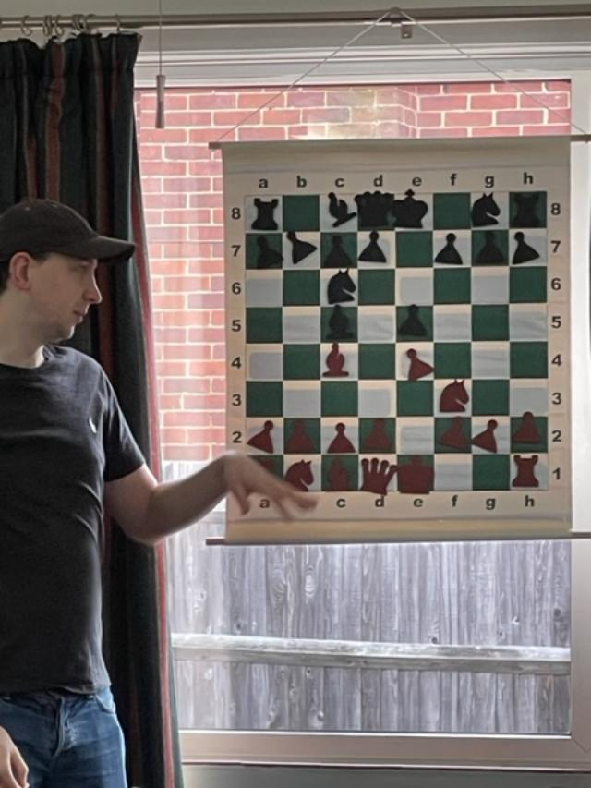

DELANCEY GIGAFINALS
The three results we know so far show good performances from the Basingstoke youngsters. At under 14 Liam Durangparang scored an impressive 4 ½ out of 7. At under 12 Edison Brown had a strong showing as always in the Delancey with a very impressive 5 out of 7. Reuben Jirgens did well at the under 8s to achieve 2 ½ out of 6 in a strong field.
JUNIOR CHESS CLUB
Confirmation that the Junior Chess Club season will restart on Wednesday 13th September 2023. The sessions will be from 5.30pm until 7.00pm.
STEVEN JONES COACHING
No date has been fixed for the next session. However a thought to be discussed with Steven is to review key positions from his British Championship games. If this is possible notice will be given.

STUART KNOX :
Please see another interesting attachment kindly provided by Stuart Knox.
FRIENDLY MATCH: Basingstoke v Andover Wednesday 16th August 2023
A 7 or 8 board match at home has been arranged with Andover. The time limit is 75 minutes all moves. Please advise if you wish to be considered for selection for this match.

CLUB WEBSITE: Keep up to date with Basingstoke Chess Club news from the club’s website. https://www.basingstokechessclub.co.uk/

Best Regards, DAVID

